- 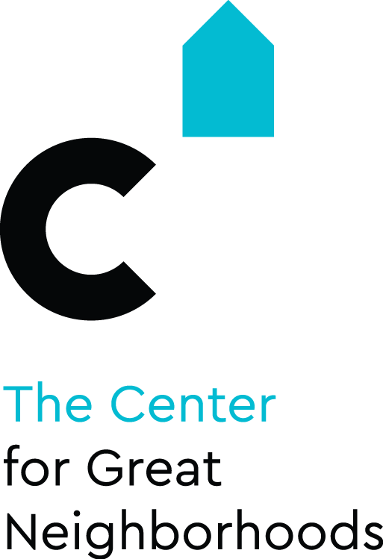

- Creative Community Grant
- Round 7

Made Possible by Support from

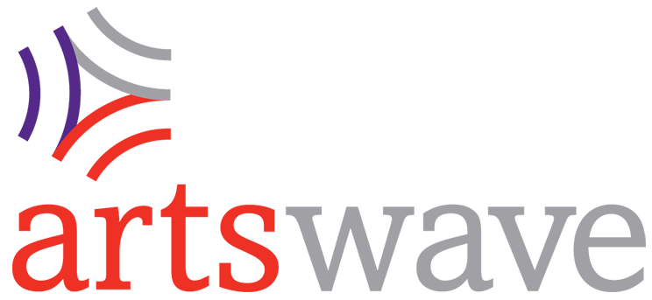

- Guidelines and Application

Program Overview
This exciting initiative is brought to you by The Center for Great Neighborhoods of Covington (The Center), made possible through ArtsWave. This program gives artists the opportunity to team up with residents and community groups to create transformative change in our city.

These guidelines provide some basic information on where The Center is targeting this support, how the program works, and how to submit your application materials. We encourage you to review this document while filling out the grant application. You are strongly encouraged to contact us before submitting an application. We are happy to help if you have questions, want advice, or need help thinking through an idea.

The Center for Great Neighborhoods: The Center for Great Neighborhoods is a 501(c)3 not-for-profit community development organization that helps residents improve their lives as they improve their communities. Since 1976, The Center has been strengthening urban neighborhoods in Covington, KY, through innovative programs in the areas of creative placemaking, community organizing, leadership development, housing development, youth engagement, and financial education. The Center equips residents with the tools to discover and develop their capacities, gain access to resources, and actively contribute to positive community development that advances the well-being of the entire neighborhood.

Please remember:
- All projects must be a creative effort to address the identified topic and build on assets in the community. See the topic on the next page.
- To apply, you must be working with a self-identified artist or an arts-related business. We define this really broadly; see the definitions below.
- Applications are limited to 5 pages plus attachments. Attachments may include examples of artists’ work.
- All applications must be received at The Center no later than 4pm on June 18, 2018. Any application received after the deadline date and time, regardless of postmark date, will not be eligible for review.

Please mail, email, or hand deliver applications to:

ATTN: Shannon Ratterman
The Center for Great Neighborhoods
321 W.MLK/12th Street
Covington, KY 41011
shannon@greatneighborhoods.org

Important Definitions
Artist: The term artists includes but is not limited to individuals and groups engaging in music, dance, drama, performance, folk art, architecture, landscape architecture, painting, sculpture, photography, graphic and craft arts, industrial design, food, costume and fashion design, motion pictures, television, radio, film, video tape and sound recording. An artist does not necessarily have to derive income from their work, but can apply as a business. Artists are self-identified but will need to provide examples of previous work to demonstrate capacity to complete the project.

Creative Placemaking: Any artistic or creative effort to make a particular community stronger.

Topic for this round: For this round, we are focusing on the topic using art to connect families to each other and their community. Some possible examples of projects we could fund are family art classes, co-creation of public art, interactive installation that connects people to their community, community theater, or many other projects that could be justified as fitting this theme. We’re open to a variety of different approaches to this issue. If you have an idea you think matches the criteria, you’re encouraged to contact us and let us give feedback to help strengthen your application.

Populations underserved by the arts: It is a priority for this program that the projects are open, inclusive, and make efforts to reach populations that may not have easy access to arts programming. The National Endowment for the Arts lists time, cost, access, and lack of people to go with as the four top barriers for people to attend arts programs. Populations that have difficulty accessing the arts may include low income individuals, busy families, non-native English speakers, and people with disabilities. It is important that your project considers these barriers and has strategies to address them.

Funding Criteria & Project Eligibility
What is the Creative Community Grant Program?
As part of The Center’s efforts to empower resident-led groups to complete community improvement projects, we are creating a pool of funds that are available to artists who can propose creative approaches to a specific community-identified issue or topic.

How much funding is available & how much can someone apply for?
We have $14,000 available to grant out and hope to make at least 4 grant awards. Each application can request up to $3500 for their project. This is a change from previous rounds of this grant program because the funding source and the quantity of funds available has changed.

Who can apply?
The applications are open to anyone who identifies themselves as an artist and is engaged in one of the arts-related disciplines listed previously. This could be an individual or a group, a hobby or a business. Artists do not necessarily need to live or work in Covington, but applicants should identify a connection to the community and a direct community benefit. Applicants can submit more than one application per round; but can receive no more than one award per round. The lead applicant must be over 18.

Where can projects take place?
Anywhere in Covington. You can specify a location or let us help you find one.

What kinds of projects are eligible for support?
The project must be artist-led, and the application must present a strong case for how the proposed project idea will creatively address the identified issue or topic. All projects must be open and inclusive, involve the community in the project, and provide a direct benefit to the community. The artist must be able to provide previous examples of work that prove a sufficient capacity to be able to complete the project as outlined. The artist should also make a strong case for how they will include the community in their project. Projects must be able to be completed within six months from the date of award. Funding is not eligible for projects that are already completed or partially underway.

Application Preparation
The Center for Great Neighborhoods will work with any artist to assist them in applying for these funds. We will provide assistance with thinking through, designing, and implementing your project. We realize that not all applicants are familiar with Covington or have experience leading community projects. We would love to talk with you while you’re coming up with a concept and help identify connections that will make your application stronger. We can also review your application and budget before it is submitted to the Review Panel to help you put the best application forward. If you have any questions or would like assistance, please contact:
Shannon Ratterman
Program Manager, Community Development
859-866-7524
shannon@greatneighborhoods.org

Funding Decisions & Timeline
Grant decisions are made through a review process involving the Creative Community Grant Review Panel. A sample score sheet is attached to this application. The Review Panel is made up of two professionals in arts related fields, two residents, and one staff person. After proposals are read by the Review Panel, grant seekers may be invited to discuss their proposal or may be sent additional questions.

Applications Due: 4pm on June 18, 2018
Funding Decisions Made: July 1, 2018
Project Completion: no later than December 31, 2018.

Financial Management
Your project budget should specify how you plan to spend the money awarded. All grant awards will be disbursed through The Center for Great Neighborhoods. We will write a check for 50% of the award amount after awards are announced and a letter of agreement has been signed and all other paperwork is turned in, including a W-9. A check for 35% of the award amount will be written at the project’s midterm check in. The final check for 15% of the award amount will be written at project completion. We will write checks directly to an individual, organization, or business.

At the conclusion of the project, the applicant must submit a completed report. This report must include a detailed budget of how funds were expended and copies of all receipts or invoices. An artist may use funds to compensate themselves for their time and skills. These fees should also be properly documented and an invoice should be created to serve as documentation of how the funds were spent.

Project Implementation and Reporting
All funded projects will be assigned a staff person as a liaison. This staff person can provide assistance in implementing your project and will be checking in with you regularly to ensure that the project is proceeding as planned. Staff from The Center is here to help your project be successful, so please take full advantage of this resource!

Application
Contact Information
Name of organization/group/business:
Full Name of Primary Contact Person:
Mailing Address:
Phone:
Email:
Organization/Group/Business/Individual Website Address:

Project Description
Project Name:
Project Location:
You can be as specific or general as your project requires. If you have a very specific location or area in mind, please tell us. Or if you’re open to working with us on finding a site, please let us know that too.

Total Project Funding Request: $

Please provide a short description of your proposed project (100 words or less):
Think of this as a brief explanation that could appear in a press release or other publicity document.

Project Strategy
1) Explain your project idea. What makes your idea innovative or unique?

2) Explain how your project uses art to connect families to each other and the community.

3) Please provide a timeline for your project.

4) What impact do you anticipate your proposed project will have on the surrounding neighborhood and the city as a whole? How will this project benefit the community and who, specifically, will benefit?

5) How will you involve community residents, resident organizations, and organizations doing neighborhood work in your project? Explain how you will reach residents typically underserved* by arts programs.
*See definition on page 2

6) Describe your existing relationship to the Covington community. Do you live here, work here, have involvement with existing Covington community organizations, etc.?
It is not a requirement of the grant program that you have existing ties to the community or its organizations. If you do not have an existing relationship, describe how you will work to establish this connection.

7) Describe your experience completing this type of project. If applicable, please attach up to 3 examples of previous work. These examples can be photos of work or links to examples found online. Please note, we will not be able to accept samples in other forms or return work samples.

8) Describe your experience in leading collaborative arts projects and/or community projects.
If you do not have previous experience with community projects, describe who you might work with to gain this experience.

9) How will you know that your proposed project is successful? What do you hope to accomplish? Briefly describe how you will measure success.

10) How much of the grant funds will you use to compensate yourself for your own time on the project? Please describe why you feel that this amount is appropriate, relative to the amount of time the project is going to require.

11) Is the project dependent on approval from another entity (e.g. City, School Board, other property owner)? Identify who you might need to get approval from and how you think you might do this.

Project Budget

EXPENSE DESCRIPTION  EXAMPLE | CREATIVE COMMUNITY GRANT FUNDS | OTHER FUNDS* | TOTAL
Paint | $250 | $0 | $500
Artist Time | $500 | $0 | $500
Publicity Costs (printing flyers) | $100 | $0 | $100
TOTAL |  |  | $1,100

*It is not required or expected that other funds be used on your project, but if the Creative Community grant funds are only partially funding your project, please let us know how much the other funds are and where they are coming from.

Certification & Liability release
I hereby certify that the information included in this application is true and accurate and that I have not misrepresented or falsified anything contained. I certify that I am authorized to act on behalf of the business/organization/group that I have referenced in this application.

I hereby release The Center for Great Neighborhoods and the staff, officers, board of trustees, contractors and funders of The Center for Great Neighborhoods, without limitation, and any and all persons involved in receiving, distributing, and reviewing my Creative Community Grant application from any and all liability, loss, or claim related to the Creative Community Grant Program and my application therefor, including without limitation, the damage or loss of my application and related materials.

I, as an applicant to the Creative Community Grant Program, have read, understand and agree to the Certification and Liability Release conditions as detailed above.

Signature of Applicant Date

Panelist score sheet (Example)
Project Name: Total: | Strongly Disagree |  |  |  | Neither Agree/  Disagree |  |  |  |  | Strongly Agree
The applicant’s idea addresses the community-identified topic well. | 0 | 1 | 2 | 3 | 4 | 5 | 6 | 7 | 8 | 9 | 10
The proposed project is very likely attract families to participate. | 0 | 1 | 2 | 3 | 4 | 5 | 6 | 7 | 8 | 9 | 10
The applicant’s idea is very innovative and unique. | 0 | 1 | 2 | 3 | 4 | 5 | 6 | 7 | 8 | 9 | 10
The proposed project is very likely to have a positive impact on the community/neighborhood. | 0 | 1 | 2 | 3 | 4 | 5 | 6 | 7 | 8 | 9 | 10
The applicant’s plans for engaging* community/neighborhood residents in their proposed project are very strong. | 0 | 1 | 2 | 3 | 4 | 5 | 6 | 7 | 8 | 9 | 10
The applicant’s plans for engaging resident groups typically underserved by arts programs is very strong. | 0 | 1 | 2 | 3 | 4 | 5 | 6 | 7 | 8 | 9 | 10
The applicant demonstrates a strong understanding of the community/neighborhood. | 0 | 1 | 2 | 3 | 4 | 5 | 6 | 7 | 8 | 9 | 10
The applicant has clearly demonstrated the ability to carry out the proposed project with a high level of artistic quality. | 0 | 1 | 2 | 3 | 4 | 5 | 6 | 7 | 8 | 9 | 10
The applicant clearly has the administrative plan and capacity to carry out the proposed project. | 0 | 1 | 2 | 3 | 4 | 5 | 6 | 7 | 8 | 9 | 10
I like this project. | 0 | 1 | 2 | 3 | 4 | 5 | 6 | 7 | 8 | 9 | 10
*Community engagement could occur during project conception, implementation, or during or after installation; whichever makes the
most sense for the type of project being described.

