- myNKY Nano Grant Pilot Program
- 2017 Guidelines and Application

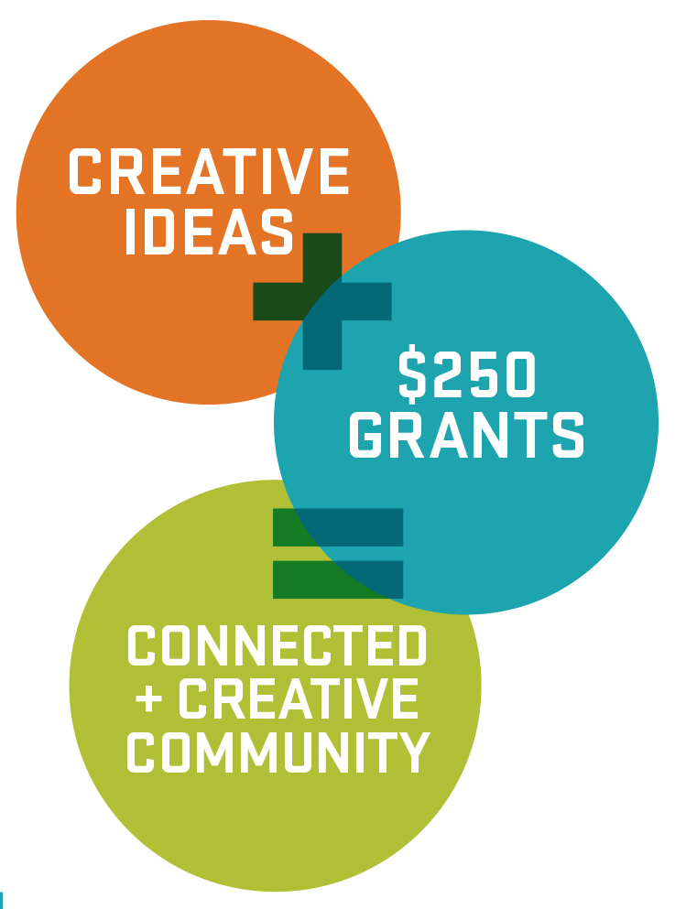

Brought to you by
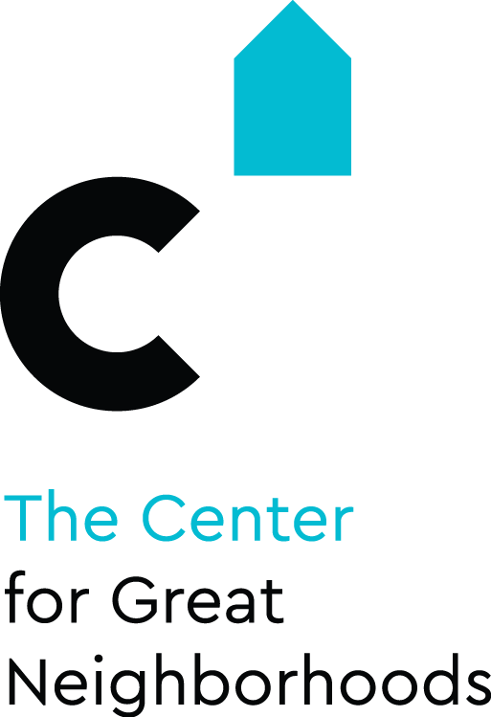

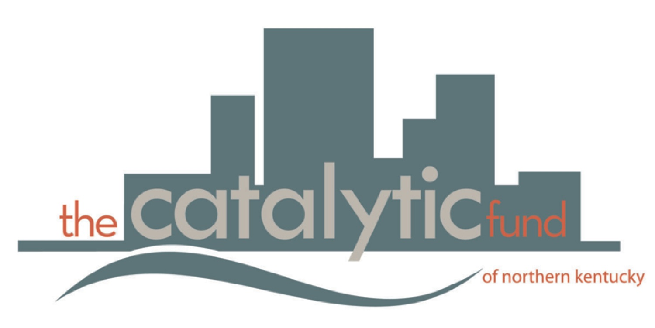

Program Overview
The myNKY Nano Grant Program is brought to you by the Catalytic Fund and the Center for Great Neighborhoods (The Center). This program aims to encourage creative solutions to local problems. Wewould like to invest in Northern Kentucky residents, students, and workers with creative ideas to strengthen the community. It is our hope that the myNKY Nano Grant Pilot Program will allow for experimentation and exploration of creative ways to build community. The pilot program began in three different communities: one urban (Dayton, KY), one suburban (Florence), and one rural (Pendleton County), and is adding three more in 2017.

Funding will be available in Summer 2017 in three funding windows, depending upon the community for which you are applying.

Proposal Eligibility
Any individual who is a resident, student or worker (works at least 15 hours/week) in a pilot community is eligible to apply for a myNKY Nano Grant of up to $250 for creative place-making projects or activities. Creative place-making is defined as any artistic or creative effort to make your neighborhood or community stronger. If you are a youth applicant, under the age of 18, you must live in a pilot community and have a consent form signed by your parent/legal guardian.

Project Eligibility
The Catalytic Fund and The Center for Great Neighborhoods are seeking creative projects that bring Northern Kentuckians together, build a sense of community, celebrate our differences, and foster community pride. Every project should contain at least one accessible element that is free to the public. Eligible projects should not exclude groups of people socially or politically and should embrace myNKY’s values of inclusion (learn more at SkywardNKY.org). Additionally, your project budget should specify how you plan to spend the money awarded. Funding cannot be used for projects that are already completed or partially underway. All projects should be completed within three months of receiving funding.

Funding Criteria
In general, projects that address multiple points of the criteria will be the strongest candidates for funding. In addition, projects should be well-planned, feasible, and able to be completed within three months of approval.
- The applicant is a resident, student or worker (works at least 15 hours/week) in a program community (Dayton, Florence or Pendleton County, Kentucky and three others as yet to be named).
- Project funding is not being used for projects that are already completed or partially underway.
- The project benefits the community.
- The project brings Northern Kentuckians together, builds a sense of community, celebrates our differences and/or fosters community pride in a creative way.
- The project is new and innovative.
- The project includes a free, publicly accessible element.
Funding Decisions
Grant decisions are made through a staff review process. Staff will consider the funding criteria stated above. Staff will not take part in the review process if the applicant is family by blood, marriage or adoption; a business associate or someone who they have a financial interest in; or whose existing personal relationship precludes an objective review. Staff may elect to fund a project in full, or may choose to only fund a portion of the proposed project. All applicants will receive notification of funding decisions within 10 days after application deadline.

Submitting your Application
Applications can be submitted online by visiting www.greatneighborhoods.org OR www.theCatalyticFund and clicking on “Apply for a Nano Grant.”
Applicants can also email, mail, or drop off their application to:
ATTN: Kate Greene
Center for Great Neighborhoods
Hellmann Creative Center, 321 West 12th Street
Covington, KY 41011
kate@greatneighborhoods.org

Contact Us
If you have any questions about the Nano Grant Program or the application process, please contact Kate Greene at 859.803.8963 or kate@greatneighborhoods.org.

Deadline is August 31st, 2017 by 5 PM
Application

- Name:
- Mailing Address:
- Phone:
- Email:
- Total Amount Requested: $______
- Are you a resident, student or worker in Dayton, Florence or Pendleton County? Please specify.
- What is your project name?
- Explain your project idea.

- The Catalytic Fund and The Center would like to fund new, innovative ideas. Have you implemented this project before? If so, how is this project different than before?

- How is this a creative place-making project (creative place-making is defined as an artistic or creative effort to make your neighborhood or community stronger)?

- How will your project bring people together? How will it engage the community?

- When & where will you implement your project? Please be as specific as possible. Remember: projects must be completed within three months of receiving funding.

- Will you need to get approval from the City, County or somebody else? If so, from whom and do you need us to help you with that process?

Project Budget

EXPENSE DESCRIPTION | COST
2 cans of paint  EXAMPLE | $80
TOTAL COST | $80

Certification & Liability Release

I hereby certify that the information included in this application is true and accurate and that I have not misrepresented or falsified anything contained. I certify that I am authorized to act on behalf of the business/organization/group that I have referenced in this application.
I hereby release the Catalytic Fund and the Center for Great Neighborhoods and the staff, officers, board of trustees, contractors and funders of the Catalytic Fund and of the Center for Great Neighborhoods, without limitation, and any and all persons involved in receiving, distributing, and reviewing my Nano Grant application from any and all liability, loss, or claim related to the myNKY Nano Grant Pilot Program and my application therefor, including without limitation, the damage or loss of my application and related materials. I, as an applicant to the Nano Grant Program, have read, understand and agree to the Certification and Liability Release conditions as detailed above.

Signature of Applicant Date

